*def* build_and_compile_model(*norm*):

  model = keras.Sequential([

      norm,

      layers.Dense(64, activation='sigmoid'),

      layers.Dense(64, activation='sigmoid'),

      layers.Dense(1)

  ])

  model.compile(loss='mean_absolute_error',

                optimizer=tf.keras.optimizers.Adam(0.001)) #loss = 'mse'

  return model

**RESULTS**

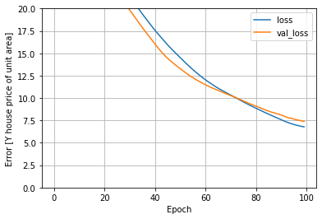

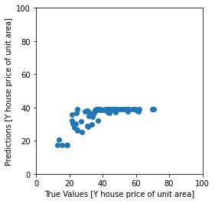

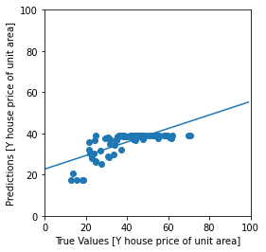

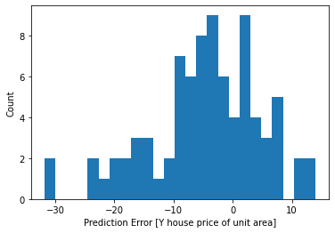

*def* build_and_compile_model(*norm*):

  model = keras.Sequential([

      norm,

      layers.Dense(64, activation='relu'),

      layers.Dense(64, activation='relu'),

      layers.Dense(1)

  ])

  model.compile(loss='mean_absolute_error',

                optimizer=tf.keras.optimizers.Adam(0.001)) #loss = 'mse'

  return model

**RESULTS**

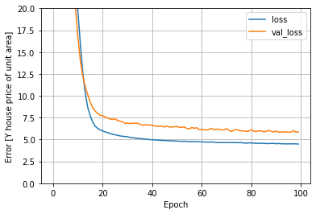

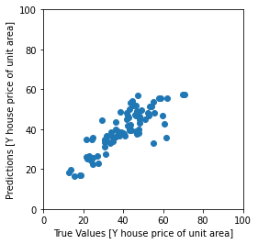

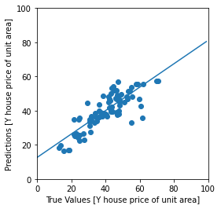

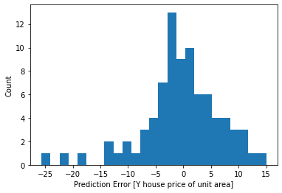

*def* build_and_compile_model(*norm*):

  model = keras.Sequential([

      norm,

      layers.Dense(64, activation='tanh'),

      layers.Dense(64, activation='tanh'),

      layers.Dense(1)

  ])

  model.compile(loss='mean_absolute_error',

                optimizer=tf.keras.optimizers.Adam(0.001)) #loss = 'mse'

  return model

**RESULTS**

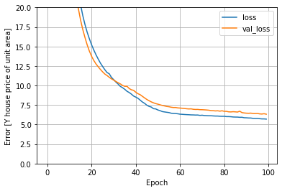

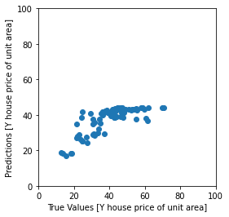

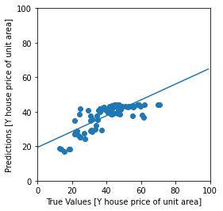

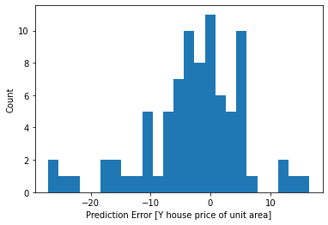

*def* build_and_compile_model(*norm*):

  model = keras.Sequential([

      norm,

      layers.Dense(64, activation='relu'),

      layers.Dense(1)

  ])

  model.compile(loss='mean_absolute_error',

                optimizer=tf.keras.optimizers.Adam(0.001)) #loss = 'mse'

  return model

**RESULTS**

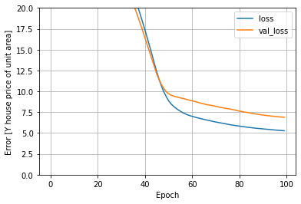

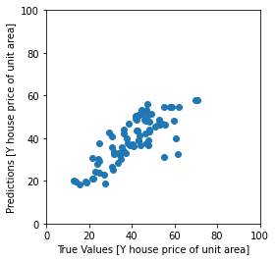

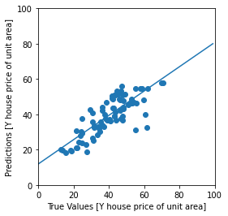

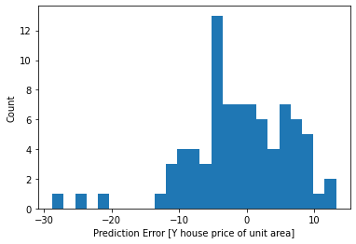

*def* build_and_compile_model(*norm*):

  model = keras.Sequential([

      norm,

      layers.Dense(64, activation='relu'),

      layers.Dense(64, activation='relu'),

      layers.Dense(64, activation='relu'),

      layers.Dense(1)

  ])

  model.compile(loss='mean_absolute_error',

                optimizer=tf.keras.optimizers.Adam(0.001)) #loss = 'mse'

  return model

**RESULTS**

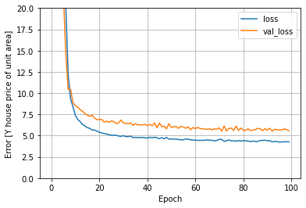

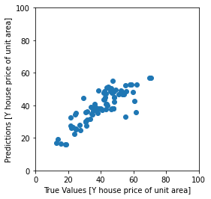

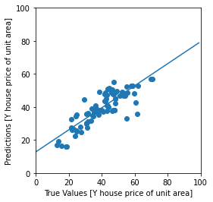

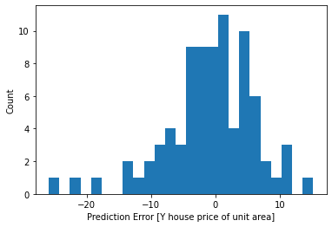

*def* build_and_compile_model(*norm*):

  model = keras.Sequential([

      norm,

      layers.Dense(64, activation='relu'),

      layers.Dense(64, activation='relu'),

      layers.Dense(64, activation='relu'),

      layers.Dense(64, activation='relu'),

      layers.Dense(1)

  ])

  model.compile(loss='mean_absolute_error',

                optimizer=tf.keras.optimizers.Adam(0.001)) #loss = 'mse'

  return model

**RESULTS**

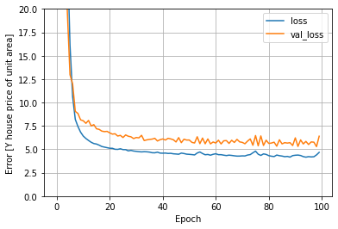

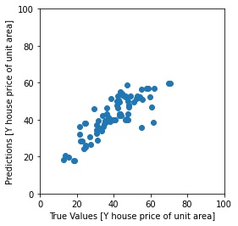

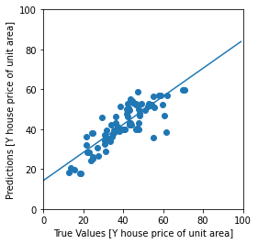

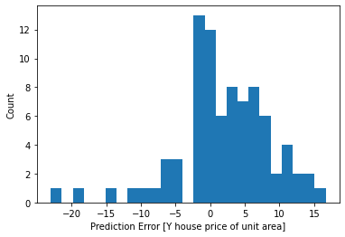

*def* build_and_compile_model(*norm*):

  model = keras.Sequential([

      norm,

      layers.Dense(64, activation='relu'),

      layers.Dense(64, activation='relu'),

      layers.Dense(64, activation='relu'),

      layers.Dense(64, activation='relu'),

      layers.Dense(64, activation='relu'),

      layers.Dense(1)

  ])

  model.compile(loss='mean_absolute_error',

                optimizer=tf.keras.optimizers.Adam(0.001)) #loss = 'mse'

  return model

**RESULTS  
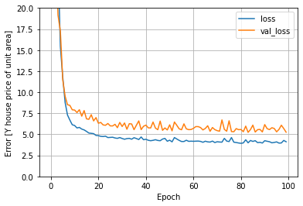**

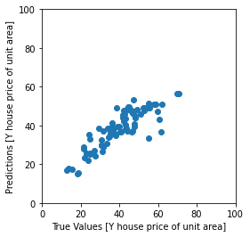

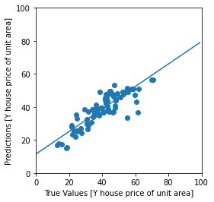

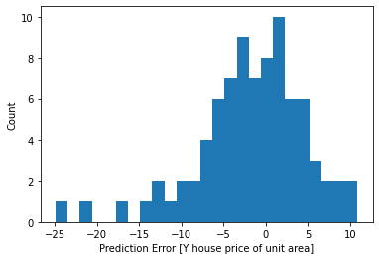

*def* build_and_compile_model(*norm*):

  model = keras.Sequential([

      norm,

      layers.Dense(64, activation='relu'),

      layers.Dense(64, activation='relu'),

      layers.Dense(64, activation='relu'),

      layers.Dense(64, activation='relu'),

      layers.Dense(64, activation='relu'),

      layers.Dense(64, activation='relu'),

      layers.Dense(1)

  ])

  model.compile(loss='mean_absolute_error',

                optimizer=tf.keras.optimizers.Adam(0.001)) #loss = 'mse'

  return model

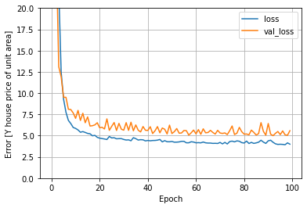

**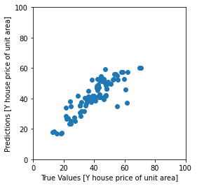  
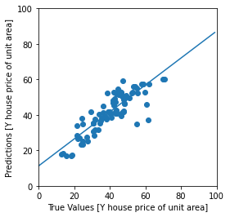**

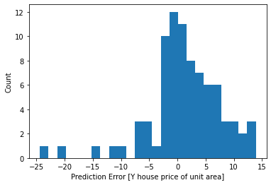

*def* build_and_compile_model(*norm*):

  model = keras.Sequential([

      norm,

      layers.Dense(64, activation='relu'),

      layers.Dense(64, activation='relu'),

      layers.Dense(64, activation='relu'),

      layers.Dense(64, activation='relu'),

      layers.Dense(64, activation='relu'),

      layers.Dense(64, activation='relu'),

      layers.Dense(64, activation='relu'),

      layers.Dense(1)

  ])

  model.compile(loss='mean_absolute_error',

                optimizer=tf.keras.optimizers.Adam(0.001)) #loss = 'mse'

  return model

**RESULTS**

